SHOPPING CHATBOT WITH AI

Project Report
Submitted by
JISHANTHI R

Course:Generative Artificial Intelligence
College:Rajalakshmi Engineering College

1. Abstract
This Shopping Chatbot system is an AI-powered platform designed to help users discover products using natural language queries.
It integrates Machine Learning and conversational AI to provide recommendations similar to real-world platforms like e-commerce websites.
The system consists of a Flask backend, modular routes, and a responsive frontend interface. Users can search for products, interact with chatbot APIs,
and view intelligent recommendations.
The architecture follows a modular approach including:
- Chat Module
- Product Module
- UI Pages
- Database Layer
This system enhances user experience by mimicking human-like assistance in online shopping environments.
This Shopping Chatbot system is an AI-powered platform designed to help users discover products using natural language queries.
It integrates Machine Learning and conversational AI to provide recommendations similar to real-world platforms like e-commerce websites.
The system consists of a Flask backend, modular routes, and a responsive frontend interface. Users can search for products, interact with chatbot APIs,
and view intelligent recommendations.
The architecture follows a modular approach including:
- Chat Module
- Product Module
- UI Pages
- Database Layer
This system enhances user experience by mimicking human-like assistance in online shopping environments.

2. Introduction
This Shopping Chatbot system is an AI-powered platform designed to help users discover products using natural language queries.
It integrates Machine Learning and conversational AI to provide recommendations similar to real-world platforms like e-commerce websites.
The system consists of a Flask backend, modular routes, and a responsive frontend interface. Users can search for products, interact with chatbot APIs,
and view intelligent recommendations.
The architecture follows a modular approach including:
- Chat Module
- Product Module
- UI Pages
- Database Layer
This system enhances user experience by mimicking human-like assistance in online shopping environments.
This Shopping Chatbot system is an AI-powered platform designed to help users discover products using natural language queries.
It integrates Machine Learning and conversational AI to provide recommendations similar to real-world platforms like e-commerce websites.
The system consists of a Flask backend, modular routes, and a responsive frontend interface. Users can search for products, interact with chatbot APIs,
and view intelligent recommendations.
The architecture follows a modular approach including:
- Chat Module
- Product Module
- UI Pages
- Database Layer
This system enhances user experience by mimicking human-like assistance in online shopping environments.

3. Problem Statement
This Shopping Chatbot system is an AI-powered platform designed to help users discover products using natural language queries.
It integrates Machine Learning and conversational AI to provide recommendations similar to real-world platforms like e-commerce websites.
The system consists of a Flask backend, modular routes, and a responsive frontend interface. Users can search for products, interact with chatbot APIs,
and view intelligent recommendations.
The architecture follows a modular approach including:
- Chat Module
- Product Module
- UI Pages
- Database Layer
This system enhances user experience by mimicking human-like assistance in online shopping environments.
This Shopping Chatbot system is an AI-powered platform designed to help users discover products using natural language queries.
It integrates Machine Learning and conversational AI to provide recommendations similar to real-world platforms like e-commerce websites.
The system consists of a Flask backend, modular routes, and a responsive frontend interface. Users can search for products, interact with chatbot APIs,
and view intelligent recommendations.
The architecture follows a modular approach including:
- Chat Module
- Product Module
- UI Pages
- Database Layer
This system enhances user experience by mimicking human-like assistance in online shopping environments.

4. Objectives
This Shopping Chatbot system is an AI-powered platform designed to help users discover products using natural language queries.
It integrates Machine Learning and conversational AI to provide recommendations similar to real-world platforms like e-commerce websites.
The system consists of a Flask backend, modular routes, and a responsive frontend interface. Users can search for products, interact with chatbot APIs,
and view intelligent recommendations.
The architecture follows a modular approach including:
- Chat Module
- Product Module
- UI Pages
- Database Layer
This system enhances user experience by mimicking human-like assistance in online shopping environments.
This Shopping Chatbot system is an AI-powered platform designed to help users discover products using natural language queries.
It integrates Machine Learning and conversational AI to provide recommendations similar to real-world platforms like e-commerce websites.
The system consists of a Flask backend, modular routes, and a responsive frontend interface. Users can search for products, interact with chatbot APIs,
and view intelligent recommendations.
The architecture follows a modular approach including:
- Chat Module
- Product Module
- UI Pages
- Database Layer
This system enhances user experience by mimicking human-like assistance in online shopping environments.

5. Scope of the Project
This Shopping Chatbot system is an AI-powered platform designed to help users discover products using natural language queries.
It integrates Machine Learning and conversational AI to provide recommendations similar to real-world platforms like e-commerce websites.
The system consists of a Flask backend, modular routes, and a responsive frontend interface. Users can search for products, interact with chatbot APIs,
and view intelligent recommendations.
The architecture follows a modular approach including:
- Chat Module
- Product Module
- UI Pages
- Database Layer
This system enhances user experience by mimicking human-like assistance in online shopping environments.
This Shopping Chatbot system is an AI-powered platform designed to help users discover products using natural language queries.
It integrates Machine Learning and conversational AI to provide recommendations similar to real-world platforms like e-commerce websites.
The system consists of a Flask backend, modular routes, and a responsive frontend interface. Users can search for products, interact with chatbot APIs,
and view intelligent recommendations.
The architecture follows a modular approach including:
- Chat Module
- Product Module
- UI Pages
- Database Layer
This system enhances user experience by mimicking human-like assistance in online shopping environments.

6. Literature Survey
This Shopping Chatbot system is an AI-powered platform designed to help users discover products using natural language queries.
It integrates Machine Learning and conversational AI to provide recommendations similar to real-world platforms like e-commerce websites.
The system consists of a Flask backend, modular routes, and a responsive frontend interface. Users can search for products, interact with chatbot APIs,
and view intelligent recommendations.
The architecture follows a modular approach including:
- Chat Module
- Product Module
- UI Pages
- Database Layer
This system enhances user experience by mimicking human-like assistance in online shopping environments.
This Shopping Chatbot system is an AI-powered platform designed to help users discover products using natural language queries.
It integrates Machine Learning and conversational AI to provide recommendations similar to real-world platforms like e-commerce websites.
The system consists of a Flask backend, modular routes, and a responsive frontend interface. Users can search for products, interact with chatbot APIs,
and view intelligent recommendations.
The architecture follows a modular approach including:
- Chat Module
- Product Module
- UI Pages
- Database Layer
This system enhances user experience by mimicking human-like assistance in online shopping environments.

7. System Architecture
This Shopping Chatbot system is an AI-powered platform designed to help users discover products using natural language queries.
It integrates Machine Learning and conversational AI to provide recommendations similar to real-world platforms like e-commerce websites.
The system consists of a Flask backend, modular routes, and a responsive frontend interface. Users can search for products, interact with chatbot APIs,
and view intelligent recommendations.
The architecture follows a modular approach including:
- Chat Module
- Product Module
- UI Pages
- Database Layer
This system enhances user experience by mimicking human-like assistance in online shopping environments.
This Shopping Chatbot system is an AI-powered platform designed to help users discover products using natural language queries.
It integrates Machine Learning and conversational AI to provide recommendations similar to real-world platforms like e-commerce websites.
The system consists of a Flask backend, modular routes, and a responsive frontend interface. Users can search for products, interact with chatbot APIs,
and view intelligent recommendations.
The architecture follows a modular approach including:
- Chat Module
- Product Module
- UI Pages
- Database Layer
This system enhances user experience by mimicking human-like assistance in online shopping environments.

8. Technologies Used
This Shopping Chatbot system is an AI-powered platform designed to help users discover products using natural language queries.
It integrates Machine Learning and conversational AI to provide recommendations similar to real-world platforms like e-commerce websites.
The system consists of a Flask backend, modular routes, and a responsive frontend interface. Users can search for products, interact with chatbot APIs,
and view intelligent recommendations.
The architecture follows a modular approach including:
- Chat Module
- Product Module
- UI Pages
- Database Layer
This system enhances user experience by mimicking human-like assistance in online shopping environments.
This Shopping Chatbot system is an AI-powered platform designed to help users discover products using natural language queries.
It integrates Machine Learning and conversational AI to provide recommendations similar to real-world platforms like e-commerce websites.
The system consists of a Flask backend, modular routes, and a responsive frontend interface. Users can search for products, interact with chatbot APIs,
and view intelligent recommendations.
The architecture follows a modular approach including:
- Chat Module
- Product Module
- UI Pages
- Database Layer
This system enhances user experience by mimicking human-like assistance in online shopping environments.

9. Implementation
This Shopping Chatbot system is an AI-powered platform designed to help users discover products using natural language queries.
It integrates Machine Learning and conversational AI to provide recommendations similar to real-world platforms like e-commerce websites.
The system consists of a Flask backend, modular routes, and a responsive frontend interface. Users can search for products, interact with chatbot APIs,
and view intelligent recommendations.
The architecture follows a modular approach including:
- Chat Module
- Product Module
- UI Pages
- Database Layer
This system enhances user experience by mimicking human-like assistance in online shopping environments.
This Shopping Chatbot system is an AI-powered platform designed to help users discover products using natural language queries.
It integrates Machine Learning and conversational AI to provide recommendations similar to real-world platforms like e-commerce websites.
The system consists of a Flask backend, modular routes, and a responsive frontend interface. Users can search for products, interact with chatbot APIs,
and view intelligent recommendations.
The architecture follows a modular approach including:
- Chat Module
- Product Module
- UI Pages
- Database Layer
This system enhances user experience by mimicking human-like assistance in online shopping environments.

19. Future Enhancements
This Shopping Chatbot system is an AI-powered platform designed to help users discover products using natural language queries.
It integrates Machine Learning and conversational AI to provide recommendations similar to real-world platforms like e-commerce websites.
The system consists of a Flask backend, modular routes, and a responsive frontend interface. Users can search for products, interact with chatbot APIs,
and view intelligent recommendations.
The architecture follows a modular approach including:
- Chat Module
- Product Module
- UI Pages
- Database Layer
This system enhances user experience by mimicking human-like assistance in online shopping environments.
This Shopping Chatbot system is an AI-powered platform designed to help users discover products using natural language queries.
It integrates Machine Learning and conversational AI to provide recommendations similar to real-world platforms like e-commerce websites.
The system consists of a Flask backend, modular routes, and a responsive frontend interface. Users can search for products, interact with chatbot APIs,
and view intelligent recommendations.
The architecture follows a modular approach including:
- Chat Module
- Product Module
- UI Pages
- Database Layer
This system enhances user experience by mimicking human-like assistance in online shopping environments.

20. Conclusion
This Shopping Chatbot system is an AI-powered platform designed to help users discover products using natural language queries.
It integrates Machine Learning and conversational AI to provide recommendations similar to real-world platforms like e-commerce websites.
The system consists of a Flask backend, modular routes, and a responsive frontend interface. Users can search for products, interact with chatbot APIs,
and view intelligent recommendations.
The architecture follows a modular approach including:
- Chat Module
- Product Module
- UI Pages
- Database Layer
This system enhances user experience by mimicking human-like assistance in online shopping environments.
This Shopping Chatbot system is an AI-powered platform designed to help users discover products using natural language queries.
It integrates Machine Learning and conversational AI to provide recommendations similar to real-world platforms like e-commerce websites.
The system consists of a Flask backend, modular routes, and a responsive frontend interface. Users can search for products, interact with chatbot APIs,
and view intelligent recommendations.
The architecture follows a modular approach including:
- Chat Module
- Product Module
- UI Pages
- Database Layer
This system enhances user experience by mimicking human-like assistance in online shopping environments.

System UI Screenshots

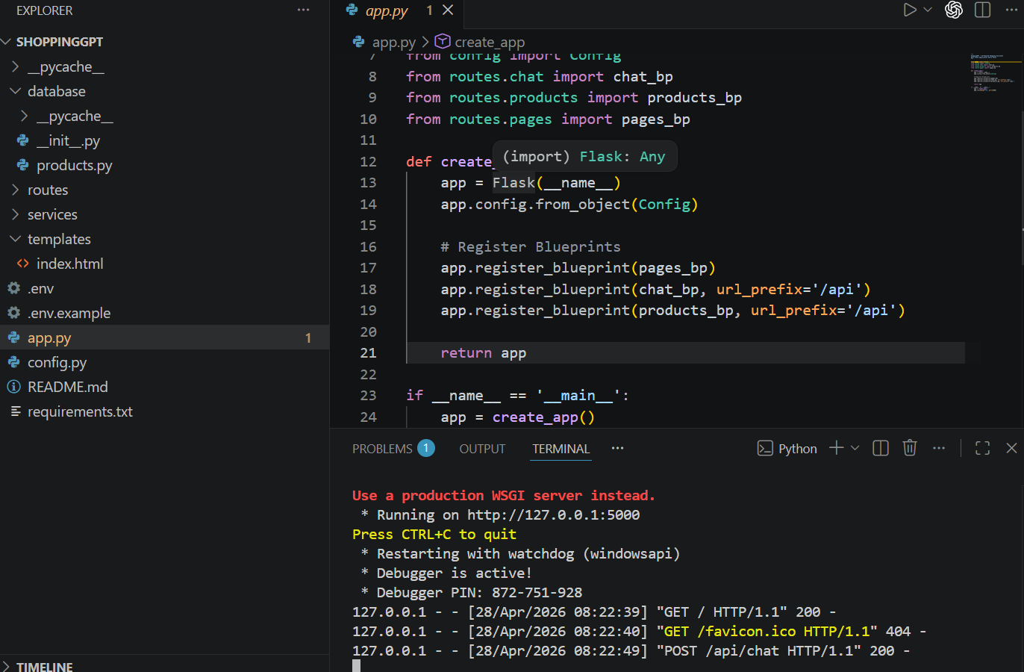

Login Page UI
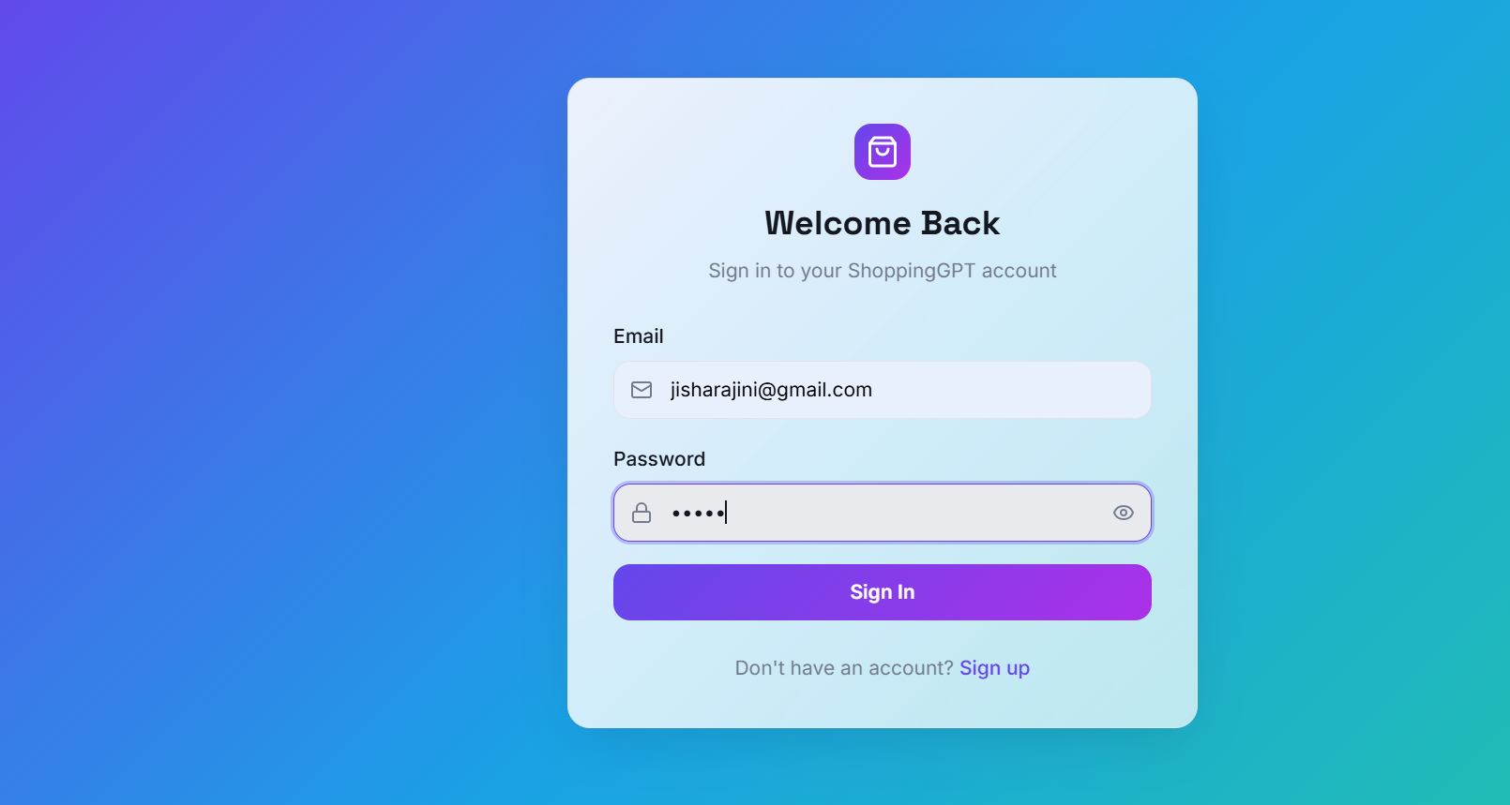
Home Page with Product Cards

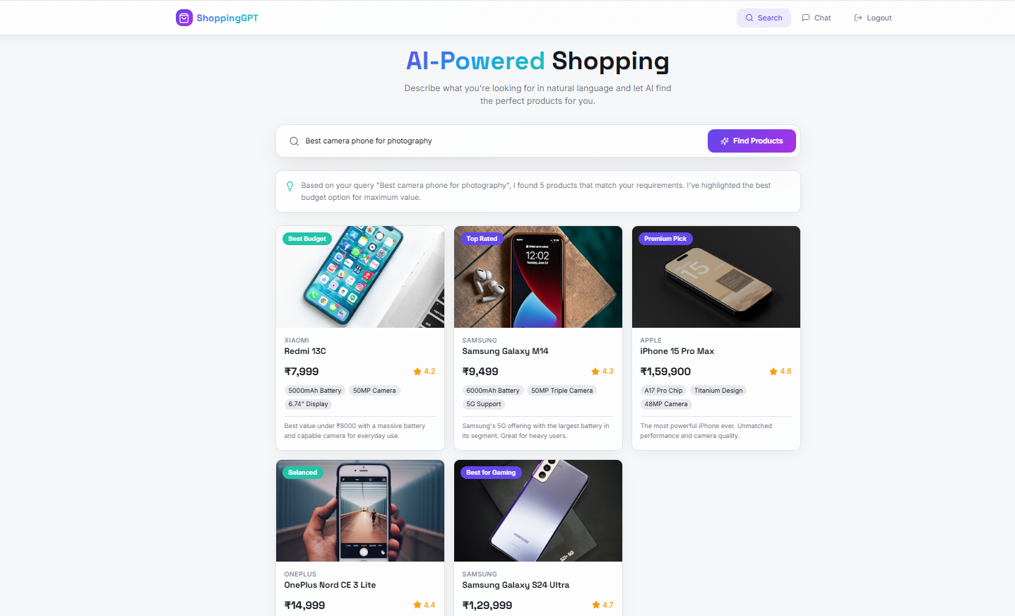

AI Product Recommendation Interface

